**A PROJECT REPORT ON**

**HOME AUTOMATION**

**SUBMITTED IN PARTIAL FULFILLMENT OF THE DEGREE**

**M.SC.IT (PART-II)**

**SUBMITTED BY**

**ARBAZ BAMBOOWALA**

**2018-2019**

**UNDER THE GUIDANCE OF**

**PROF.RAKHI GUPTA**

**AND CO-GUIDANCE OF**

**PROF.KIRTI BHATT**

**UNIVERSITY OF MUMBAI**

**MASTER OF SCINCE IN**

**INFORMATION TECHNOLOGY**

**KISHICHAND CHELLARAM COLLEGE**

**D.W.ROAD, CHURCHGATE, MUMBAI:400033**

**Acknowledgement**

After months of hard work, finally I am very happy to present my project but it wouldn’t be right to do so without thanking those who helped us to turn our thoughts into reality. So I would like to take this opportunity to thank each and every one who helped us in the completion of this project.

I would like to convey our respects to and thank the honourable principal,**Dr. Hemlata Bagla**, and our Head of Department (B.Sc IT & M.Sc IT), **Prof. Rakhi Gupta**, for providing us the opportunity to do the project work at Kishinchand Chellaram College. I am extremely thankful to them for providing such support and guidance, despite their busy schedule.

I would like to thank our project guide, **Mrs.Kirti Bhatt**  for the patient guidance, encouragement and advice she has provided throughout my time as her student. I have been extremely lucky to have a project guide who cared so much about my work, and who responded to my questions and queries so promptly.

I would like to express my gratitude and heartily thanks to **Mrs.Kirti Bhatt** for their guidance and suggestions about this project work.

I am thankful to and fortunate enough to get constant encouragement, support and guidance from our college management and the non teaching staff members. Especially to the

**Mr. Govind Varma**, who helped us in successfully completing my project work.

I would also like to thank our professors and all the other staff of the M.Sc. IT Department of our college for all the help and co-operation that they offered during the course of this project.

I am also very grateful to our parents & friends, who supported me throughout, and have provided me with all the help & support possible.

**TABLE OF CONTENTS**

|  |  |  |
| --- | --- | --- |
| **Sr. No** | **Description** | **Page No** |
| 1 | **Introduction** |  |
|  | 1.1 Abstract |  |
|  | 1.2 Problem Definition |  |
|  | 1.3 Proposed System |  |
|  | 1.4 Purpose & Scope |  |
| 2 | **Requirement & System Analysis** |  |
|  | 2.1 Feasibility Study |  |
|  | 2.2 Technology Used |  |
|  | 2.3 Hardware & Software Requirements |  |
|  | 2.4 Limitations of existing system |  |
| 3 | **System Scheduling** |  |
|  | 3.1 Project Scheduling |  |
|  | 3.2 Gantt Chart |  |
| 4 | **System Design** |  |
|  | 4.1 Data Flow Diagram |  |
|  | 4.2 Use Case Diagram |  |
|  | 4.3 Circuit Diagram |  |
|  | 4.4 Activity Diagram |  |
|  | 4.5 Entity Relationship Diagram |  |
|  | 4.6 Sequence Diagram |  |
| 5 | **System Implementation** |  |
|  | 5.1 Code listing |  |
|  | 5.2 Methodology Used |  |
| 6 | **User Manual** |  |
|  | 6.1 Screen Shots & Images |  |
|  | 6.2 Steps |  |
| 7 | **System Testing** |  |
|  | 7.1 Testing Methodology |  |
|  | 7.2 Testing Methodology Adopted |  |
|  | 7.3 Test Types |  |
|  | 7.4 Test Cases |  |
| 8 | **Conclusion and Future Enhancements** |  |
|  | 8.1 Conclusion |  |
|  | 8.3 Limitations |  |
|  | 8.2 Future Enhancements |  |
| 9 | **References** |  |
|  | 9.1 Bibliography |  |
|  | 9.2 Reference |  |
|  | 9.3 Websites Used |  |

**Introduction**

**ABSTRACT**

ABSTRACT of the project is as follows:

The particular project plans at designing a basic home automation system on Raspberry Pi by accessing a web address and android application for controlling the appliances.

This system has been made such that it is very easy to install, run, configure and maintain. This system will provide the user to get a centralized control to control the house-hold appliances centrally using a portable device such as a smart phone. The system has been developed in python environment which is the default programming environment provided by Raspberry Pi. The system is connected to the GUI on the mobile phone. Results show the efficient implementation of the system for home automation. This project deals with wireless connectivity using IoT and energy efficient control of the home appliances in a user-friendly manner. The connectivity is achieved by using of Raspberry Pi and Wi-Fi. The interface between the hardware and software of the entire system is achieved by Raspberry Pi. It is connected to the internet. This also give platform to learn different technologies together – Linux, Python, and, Php.

Home automation has gained popularity due to its numerous advantages. Using this basic concept one can have a dynamic access to the Home using the Local Area Network (LAN).

**PROBLEM DEFINITION:**

* There is energy problems in current situation of the country. Moreover, people have become negligent in proper utilization of the available

energy.

* People mostly forget to put off the lights/fans and other home appliances. Even in those situations application of home automation makes it possible to control them from a distant place in easy way with our smart phone.
* People are constantly running from place to place working to accomplish everything on our never-ending “to-do” list. Because of home automation system we never have to worry about opening the door, switching off the lights/fans, to check who is at the door step and so on. In short we can save some precious time and effort and experience more daily productivity.
* There is a very high need in today's world for the technologies to be used in an efficient way. Especially for the ones who are disabled.
* This has been a very huge problem for the disabled person to take efforts to use his own household appliances.
* The senior citizens also have a huge trouble in order to again and again switch the lights and fan off and on by making efforts to reach the switch.
* They also have trouble regarding to open the main doors of the house and check who is at the door.
* There is a huge need to solve these problems. With the help of home automation the senior citizen and disabled person can easily access the appliances and open the door and check the person at the door step with their devices without the need to go to the door and check the visitor by itself. Majorly it will give a very ease in accessing the home appliances and also give an effect on saving the energy of the home.

**PROPOSED SYSTEM:**

This system is made using a Raspberry Pi which will allow the user to get a full centralized control to turn the home appliances switch on and off. The connectivity to the appliances from the mobile phone will be wireless which will provide portability to the user and also ease of access. This system will provide access to the user for more then one module. The user can get access to turn on and off the lights and fan. Also the user will be able to access the door and can view outside the door with the help of a camera. The system will allow the user to also record the video and click images using a mobile phone. System will also provide access to open and close the door of the user’s home.

**PURPOSE AND SCOPE**

**PURPOSE:**

The main objective of the home automation system is to help handicapped and senior people which will help them to use home appliances in critical situations with ease and portability also the people who forget to close the appliances. Home Automation system not only refers to reduce the human efforts but also energy efficient and time saving and cost saving.Mobile Devices are ideal in providing a friendly user interface, the are portable and has wide range of capabilities. They can communicate with the home automation network, and they require low power communication protocols, such as WI-FI. The purpose of this work is to develop an easily configured and user friendly interface, yet powerful and reliable to pro

vide its user with controlling capabilities over his home appliances.

**SCOPE:**

**User friendly interface:**

It is user friendly as the user will only need to access the mobile phone browser and a very easy to understand application using which the user will get the interface to control the appliances. The user will use either the appliance or the web browser according to the need of the appliance he wants to use.

**Fast access to Appliances:**

The user does not need to make too much effort to go and access the appliance switch to turn appliances on such as light or fan or check the door to see who has arrived and open the door. User can reach out only by means of using a mobile phone.

**Error Free:**

As the user will input only the IP address to access the web page, also connect to the mobile phone app. And there is only the users access to the interface so there is no chance of error to occur as there is only one user to access the browser or the app at a single time .

**Look and feel environment:**

The look and feel of the system is very user friendly easy to understand and also very continent to operate as it is very much easy to access the system as there is only a requirement of a smart phone and no other technical knowledge will be required for the user to operate any of the appliance.

**To Remotely Control home appliances.**

User has a remote control like feel as user can easily access the appliances from anywhere with just a touch on the smartphone without taking any of the efforts to go and reach the switch or to the door.

**To save time and utilize the energy efficiently.**

As the User can access easily even while doing some other work the user has the freedom to just tap on the buttons and the work is done. It will save efficiency of the energy as well as the user’s time.

**Limitations of the existing system:**

* Traditionally , the user had to go to the switch and make all the efforts to power on and power off the fan and lights.
* The home automation came into picture later on, The system used to control the appliances using the Bluetooth module.
* Bluetooth module used had a poor distance coverage and had a very limited speed.
* Then the home automation took advancement and was used using a Ethernet which also had issues with management of cables.

**Requirements**

**and**

**System Analysis**

**FEASIBILITY STUDY**

All projects are feasible, given unlimited resources and infinite time. But the development of software is plagued by the scarcity of resources and difficult delivery rates. It is both necessary and prudent to evaluate the feasibility of a project at the earliest possible time. Different types of feasibilities are as follows:

* Organizational and cultural feasibility
* Technical feasibility
* Economic feasibility
* Schedule feasibility
* Operational feasibility
* Resource feasibility

**Organizational and cultural feasibility:**

Cultural feasibility means how well the end user and management accept the new system. This project is feasible because of following points:

* As the process is managed by computer literate individuals, there is no phobia related to automation.
* A perceived loss of control on the system is minimal due to less work involved.

**Economic Feasibility:**

This procedure is to determine the benefits and savings that are expected from a candidate system and compare them with costs. If benefits outweigh costs, then the decision is made to design and implement the system. Otherwise, further justification or alterations in proposed system will have to be made if it is to have a chance of being approved. This is an ongoing effort that improves in accuracy at each phase of the system life cycle.

**Technical Feasibility:**

Technical feasibility centers on the existing computer system (hardware, software, etc.,) and to what extent it can support the proposed addition. If the budget is a serious constraint, then the project is judged not feasible.

**Operational Feasibility:**

People are inherently resistant to change, and computers have been known to facilitate change. It is understandable that the introduction of a candidate system requires special effort to educate, sell, and train the staff on new ways of conducting business

**Resource Feasibility:**

It is measure of availability of system resources

* Being individually developed there is no requirement for staff.
* Resources needed for development are also not very expensive.
* There is no risk of employees or staff getting transferred as these resources are not required at all.

**STAKE HOLDERS:**

A stakeholder is anybody who can affect or is affected by an organisation, strategy or project. They can be internal or external and they can be at senior or junior levels.

There are two types of stakeholders : Internal & External

Stakeholders

* + Local Community
  + Customer
  + Society
  + Government

**TECHNOLOGIES USED**

I prefer development of this system using python programming , HTML5, Php , Linux.

**PYTHON PROGRAMMING:-**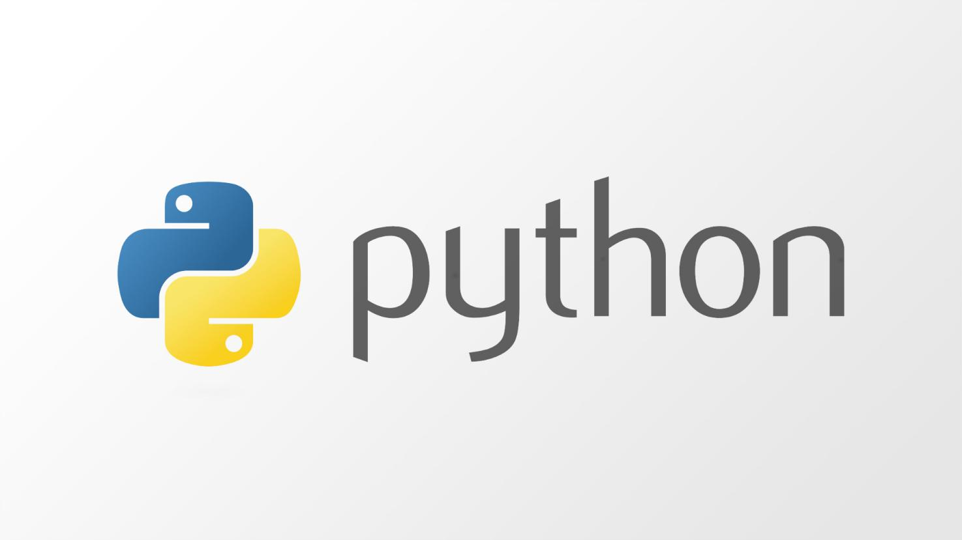

**PYTHON?:-**

Python is an [open source](https://simple.wikipedia.org/wiki/Open_source) [programming language](https://simple.wikipedia.org/wiki/Programming_language) that was made to be easy-to-read and powerful. A [Dutch](https://simple.wikipedia.org/wiki/Netherlands) programmer named [Guido van Rossum](https://simple.wikipedia.org/wiki/Guido_van_Rossum) made Python in 1991. He named it after the television show [Monty Python's Flying Circus](https://simple.wikipedia.org/wiki/Monty_Python's_Flying_Circus). Many Python examples and tutorials include jokes from the show.

Python is an interpreted language. Interpreted languages do not need to be [compiled](https://simple.wikipedia.org/wiki/Compiled_language) to run. A program called an [interpreter](https://simple.wikipedia.org/wiki/Interpreter_(computing)) runs Python code on almost any kind of computer. This means that a programmer can change the code and quickly see the results. This also means Python is slower than a compiled language like [C](https://simple.wikipedia.org/wiki/C_(programming_language)), because it is not running [machine code](https://simple.wikipedia.org/wiki/Machine_code) directly.

Python is a good programming language for beginners. It is a high-level language, which means a programmer can focus on what to do instead of how to do it. Writing programs in Python takes less time than in some other languages.

Python drew inspiration from other programming languages like C, [C++](https://simple.wikipedia.org/wiki/C++), [Java](https://simple.wikipedia.org/wiki/Java_(programming_language)), [Perl](https://simple.wikipedia.org/wiki/Perl), and [Lisp](https://simple.wikipedia.org/wiki/LISP).

Python has a very easy-to-read syntax. Some of Python's syntax comes from C, because that is the language that Python was written in. But Python uses whitespace to delimit code: spaces or tabs are used to organize code into groups. This is different from C. In C, there is a [semicolon](https://simple.wikipedia.org/wiki/Semicolon) at the end of each line and curly braces ({}) are used to group code. Using whitespace to delimit code makes Python a very easy-to-read language.

**THE USE OF PYTHON?:-**

Python is used by hundreds of thousands of programmers and is used in many places. Sometimes only Python code is used for a program, but most of the time it is used to do simple jobs while another programming language is used to do more complicated tasks.

Its [standard library](https://simple.wikipedia.org/w/index.php?title=Standard_library&action=edit&redlink=1) is made up of many functions that come with Python when it is installed. On the [Internet](https://simple.wikipedia.org/wiki/Internet) there are many other [libraries](https://simple.wikipedia.org/w/index.php?title=Library_(computing)&action=edit&redlink=1) available that make it possible for the Python language to do more things. These libraries make it a powerful language; it can do many different things.

Some things that Python is often used for are:

* Web development
* [Game](https://simple.wikipedia.org/wiki/Video_game) programming
* Desktop [GUIs](https://simple.wikipedia.org/wiki/GUI)
* Scientific programming

**WI-FI**

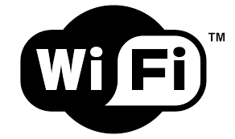

Wi-Fi is one of the most important technological developments of the modern age. It’s the wireless networking standard that helps us enjoy all the conveniences of modern media and connectivity at the tips of our fingers without astronomical cellular data charges.Wi-Fi is one of the most important technological developments of the modern age. It’s the wireless networking standard that helps us enjoy all the conveniences of modern media and connectivity at the tips of our fingers without astronomical cellular data charges. The term “Wi-Fi” is a marketing name, but it stands for “wireless fidelity.” Similar to other wireless connection types, like Bluetooth, it’s a radio transmission technology that’s built upon a set of standards to allow high-speed and secure communications between a wide variety of digital devices, access points, and hardware. It makes it possible for Wi-Fi capable devices to access the internet without the need for restrictive wires. It can operate over short and long distances, be locked down and secured, or open and free. It’s incredibly versatile and yet is easy enough to use that it’s found in the most popular of consumer devices. Wi-Fi is ubiquitous and exceedingly important for the way we operate our modern connected world.Wi-Fi devices are everywhere. Most routers offer Wi-Fi connectivity and almost any product with smart functions relies on it for a steady and strong connection to the internet. Almost all modern smart-phones support it, as do tablets, laptops, and some desktops. It can be added to computers using USB dongles too. Smart TVs almost always come with support for Wi-Fi connectivity and many internet of things devices like smart fridges and cameras do too. There are also Wi-Fi printers, scanners, clocks, games consoles, digital radios and even cars. The use cases for Wi-Fi are near infinite when you consider the wide array of connected services that any device can take advantage of it they gain wireless access to the internet.

**RASPBERRY PI:-**

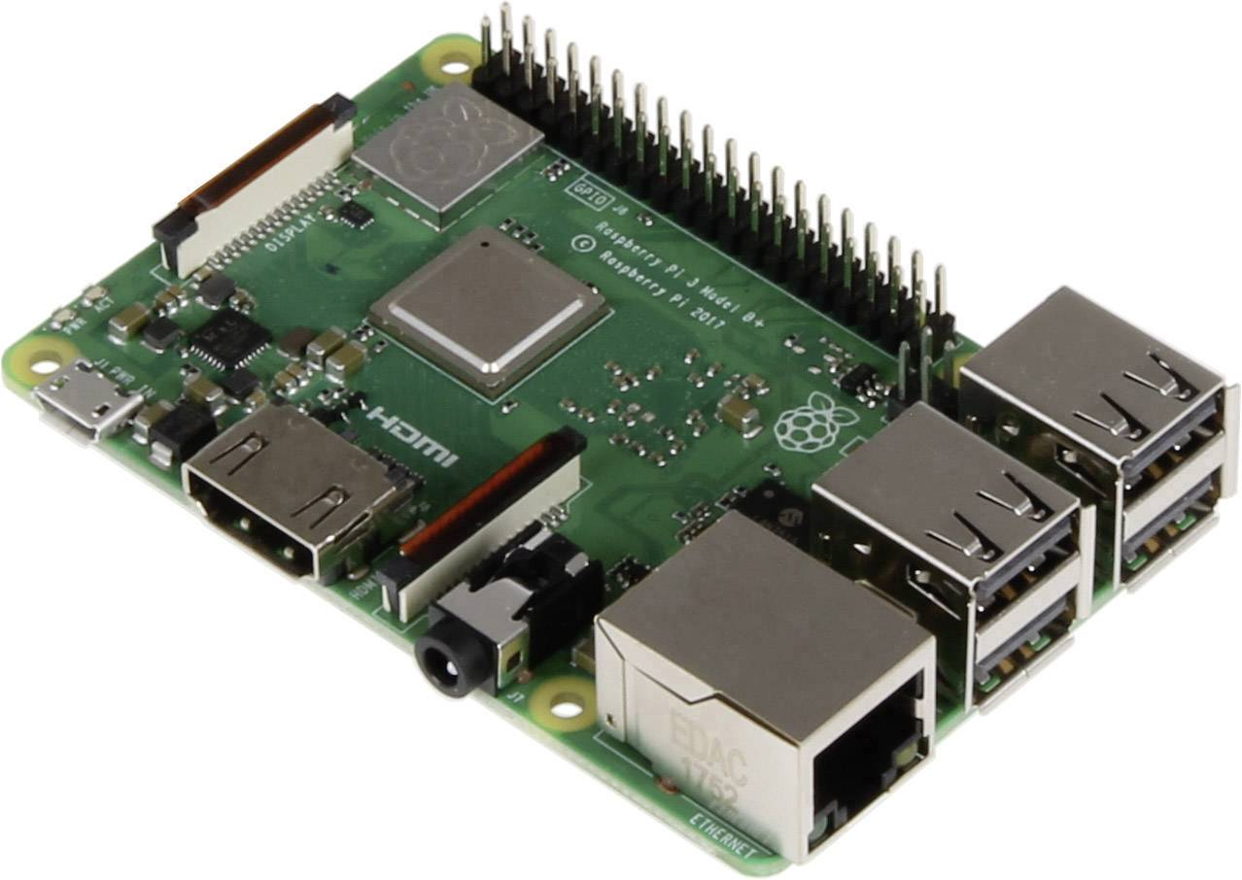

The Raspberry Pi is a series of small [single-board computers](https://en.wikipedia.org/wiki/Single-board_computer) developed in the [United Kingdom](https://en.wikipedia.org/wiki/United_Kingdom) by the [Raspberry Pi Foundation](https://en.wikipedia.org/wiki/Raspberry_Pi_Foundation) to promote the teaching of basic [computer science](https://en.wikipedia.org/wiki/Computer_science) in schools and in [developing countries](https://en.wikipedia.org/wiki/Developing_countries). The original model became far more popular than anticipated,[[8]](https://en.wikipedia.org/wiki/Raspberry_Pi) selling outside its [target market](https://en.wikipedia.org/wiki/Target_market) for uses such as [robotics](https://en.wikipedia.org/wiki/Robotics). It does not include peripherals (such as [keyboards](https://en.wikipedia.org/wiki/Keyboard_(computing)) and [mice](https://en.wikipedia.org/wiki/Mouse_(computing))) and [cases](https://en.wikipedia.org/wiki/Computer_case). However, some accessories have been included in several official and unofficial bundles.

The organisation behind the Raspberry Pi consists of two arms. The first two models were developed by the [Raspberry Pi Foundation](https://en.wikipedia.org/wiki/Raspberry_Pi_Foundation). After the Pi Model B was released, the Foundation set up Raspberry Pi Trading, with [Eben Upton](https://en.wikipedia.org/wiki/Eben_Upton) as CEO, to develop the third model, the B+. Raspberry Pi Trading is responsible for developing the technology while the Foundation is an educational charity to promote the teaching of basic computer science in schools and in developing countries. The Raspberry Pi hardware has evolved through several versions that feature variations in memory capacity and peripheral-device support. This block diagram describes Model B and B+; Model A, A+, and the Pi Zero are similar, but lack the Ethernet and USB hub components. The Ethernet adapter is internally connected to an additional USB port. In Model A, A+, and the Pi Zero, the USB port is connected directly to the system on a chip (SoC). On the Pi 1 Model B+ and later models the USB/Ethernet chip contains a five-port USB hub, of which four ports are available, while the Pi 1 Model B only provides two. On the Pi Zero, the USB port is also connected directly to the SoC, but it uses a micro USB (OTG) port. The Raspberry Pi 3, with a quad-core ARM Cortex-A53 processor, is described as having ten times the performance of a Raspberry Pi 1. This was suggested to be highly dependent upon task threading and instruction set use. Benchmarks showed the Raspberry Pi 3 to be approximately 80% faster than the Raspberry Pi 2 in parallelised tasks.

**SERVO MOTOR?**

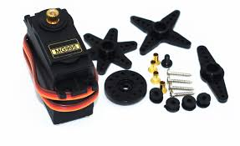

A servomotor is a rotary actuator or a linear actuator that allows for precise control of angular or linear position, velocity and acceleration. It consists of a suitable motor coupled to a sensor for position feedback. It also requires a relatively sophisticated controller, often a dedicated module designed specifically for use with servomotors.

Servomotors are not a specific class of motor although the term servomotor is often used to refer to a motor suitable for use in a closed-loop control system.

servomotor is a closed-loop servo mechanism that uses position feedback to control its motion and final position. The input to its control is a signal (either analogue or digital) representing the position commanded for the output shaft.

**OPERATING SYSTEM:-**

The Raspberry Pi Foundation provides [Raspbian](https://en.wikipedia.org/wiki/Raspbian), a Debian-based [Linux distribution](https://en.wikipedia.org/wiki/Linux_distribution) for download, as well as third-party [Ubuntu](https://en.wikipedia.org/wiki/Ubuntu_(operating_system)), [Windows 10 IoT Core](https://en.wikipedia.org/wiki/Windows_10_IoT_Core), [RISC OS](https://en.wikipedia.org/wiki/RISC_OS), and specialised [media centre](https://en.wikipedia.org/wiki/OpenELEC) distributions.

Raspbian is a [Debian](https://en.wikipedia.org/wiki/Debian)-based [computer operating system](https://en.wikipedia.org/wiki/Operating_system) for [Raspberry Pi](https://en.wikipedia.org/wiki/Raspberry_Pi). There are several versions of Raspbian including Raspbian Stretch and Raspbian Jessie. Since 2015 it has been officially provided by the [Raspberry Pi Foundation](https://en.wikipedia.org/wiki/Raspberry_Pi_Foundation) as the primary operating system for the family of Raspberry Pi [single-board computers](https://en.wikipedia.org/wiki/Single-board_computers).[[1]](https://en.wikipedia.org/wiki/Raspbian) Raspbian was created by Mike Thompson and Peter Green as an independent project.[[4]](https://en.wikipedia.org/wiki/Raspbian) The initial build was completed in June 2012. The operating system is still under active development. Raspbian is highly optimized for the Raspberry Pi line's low-performance [ARM](https://en.wikipedia.org/wiki/ARM_architecture) CPUs.

Raspbian uses PIXEL, Pi Improved X windows Environment, Lightweight as its main desktop environment as of the latest update. It is composed of a modified [LXDE](https://en.wikipedia.org/wiki/LXDE) desktop environment and the Open-box stacking window manager with a new theme and few other changes. The distribution is shipped with a copy of computer algebra program [Mathematica](https://en.wikipedia.org/wiki/Wolfram_Mathematica) and a version of Minecraft called Minecraft Pi as well as a lightweight version of Chromium as of the latest version.

The type of motor is not critical to a servomotor and different types may be used.

Most modern servomotors are designed and supplied around a dedicated controller module from the same manufacturer. Controllers may also be developed around microcontrollers in order to reduce cost for large-volume applications.

**RASPBERRY PI CAMERA:**

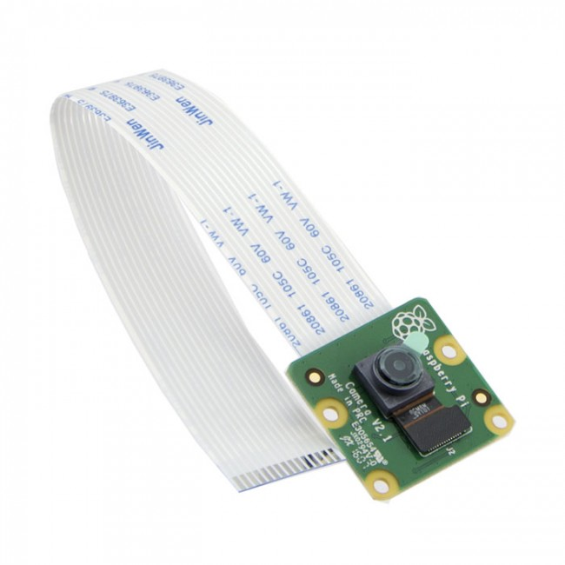

The Raspberry Pi camera module can be used to take high-definition video, as well as stills photographs. It’s easy to use for beginners, but has plenty to offer advanced users if you’re looking to expand your knowledge. There are lots of examples online of people using it for time-lapse, slow-motion and other video cleverness. You can also use the libraries we bundle with the camera to create effects.

If you’re interested in the nitty-gritty, you’ll want to know that the module has a five megapixel fixed-focus camera that supports 1080p30, 720p60 and VGA90 video modes, as well as stills capture and there are numerous third-party libraries built for it, including the Picamera Python library. The camera module is very popular in home security applications, and in wildlife camera traps. You can also use it to take snapshots.The camera consists of a small (25mm by 20mm by 9mm) circuit board, which connects to the Raspberry Pi's Camera Serial Interface (CSI) bus connector via a flexible ribbon cable. The camera's image sensor has a native resolution of five megapixels and has a fixed focus lens. The software for the camera supports full resolution still images up to 2592x1944 and video resolutions of 1080p30, 720p60 and 640x480p60/90 Installation involves connecting the ribbon cable to the CSI connector on the Raspberry Pi board. This can be a little tricky, but if you watch the videos that demonstrate how it is done, you shouldn't have any trouble.

When you purchase the camera, you will receive a small camera board and cable. You'll want to devise some method of supporting the camera in order to use it. Some camera stands and Raspberry Pi cases are now available. You can also rig up something simple yourself if you wish. I attached mine to a case using a small piece of plastic and double-sided tape

**HARDWARE AND SOFTWARE REEQUIREMENTS**

**System Requirements:-**

**The development of Home automation system requires the following resources:**

**Hardware Requirements:**

* A Raspberry PI 3 B+
* Light
* Relay Module
* Fan
* WI-FI
* Active Internet Connection
* Mouse or Keyboard
* F-F Jumper Wires,M-F Jumper Wires
* Connecting Wires
* Servo Motor
* Raspberry PI Camera.
* Smart Phone

**Software Requirements:**

* Front End ---

Android App, Php, Apache2.

* Back End ---

Python

**System**

**Scheduling**

**Project Scheduling**

|  |  |  |  |  |  |  |  |  |
| --- | --- | --- | --- | --- | --- | --- | --- | --- |
| **Sr.** | **Contents** | |  | | **Proposed** | **Submission** | **Teacher’s** | **Remark** |
| **No** |  | |  | | **Date** | **Date** | **Signature** |  |
|  |  | |  | |  |  |  |  |
| 1. | **Investigation** | |  | |  |  |  |  |
|  |  | |  | |  |  |  |  |
|  | Project Fixing | |  | | 17/7/18 | 22/8/18 |  |  |
|  |  | |  | |  |  |  |  |
|  | Synopsis | |  | | 23/8/18 | 27/8/18 |  |  |
|  |  | |  | |  |  |  |  |
| 2. | **Analysis** | |  | |  |  |  |  |
|  |  | |  | |  |  |  |  |
|  | Project history | |  | |  | 28/8/18 |  |  |
|  |  | |  | |  |  |  |  |
|  | Requirement | |  | |  | 29/8/18 |  |  |
|  | Gathering | |  | |  |  |  |  |
|  | Objective and scope of | | | | 30/8/18 | 31/8/18 |  |  |
|  | the project | |  | |  |  |  |  |
|  | Problems | | with | |  | 3/9/18 |  |  |
|  | existing system | |  | |  |  |  |  |
|  | Advantages | | of | |  | 9/9/18 |  |  |
|  | proposed system | |  | |  |  |  |  |
|  | Feasibility study | |  | |  | 11/9/18 |  |  |
|  |  | | | |  |  |  |  |
|  | Cost benefits analysis | | | |  | 18/9/18 |  |  |
|  |  | |  | |  |  |  |  |
|  | Requirement | |  | | 15/9/18 | 19/9/18 |  |  |
|  | Specification | |  | |  |  |  |  |
|  | Tools and Technology | | | |  | 20/9/18 |  |  |
|  |  | |  | |  |  |  |  |
| 3. | **Design Phase** | |  | |  |  |  |  |
|  |  | | | |  |  |  |  |
|  | Detailed Life Cycle of | | | |  | 21/9/18 |  |  |
|  | the project | |  | |  |  |  |  |
|  | (Logical design) | |  | |  |  |  |  |
|  | Circuit Diagram | |  | |  | 22/9/18 |  |  |
|  |  | |  | |  |  |  |  |
|  | Flow Diagram | |  | | 23/9/18 | 27/9/18 |  |  |
|  |  | |  | |  |  |  |  |
| 4. | **Coding Phase** | | |  |  |  |  |  |
|  |  |  | |  |  |  |  |  |
|  | Forms |  | |  | 28/9/18 | 3/10/18 |  |  |
|  |  | | |  |  |  |  |  |
|  | Modules Design | | |  |  | 6/10/18 |  |  |
|  |  | | |  |  |  |  |  |
|  | Validating Forms/ | | |  | 6/10/18 | 11/10/18 |  |  |
|  | Application | | |  |  |  |  |  |
| 5. | **Testing Phase** | | |  |  |  |  |  |
|  |  |  | | |  |  |  |  |
|  | Module | Testing/Unit | | | 12/10/18 | 26/10/18 |  |  |
|  | Testing |  | |  |  |  |  |  |
|  | Integration Testing | | | |  | 29/11/18 |  |  |
|  |  | | |  |  |  |  |  |
|  | System Testing | | |  | 30/11/18 | 5/12/18 |  |  |
|  |  | | | |  |  |  |  |
|  | Acceptance Testing | | | |  | 9/12/18 |  |  |
|  |  | | |  |  |  |  |  |
| 6. | **Evaluation** | | | **and** |  |  |  |  |
|  | **Enhancement** | | |  |  |  |  |  |
|  | System | maintenance | | | 7/1/19 | 25/1/19 |  |  |
|  | and future |  | |  |  |  |  |  |
|  | Enhancement | | |  |  |  |  |  |
|  |  | | |  |  |  |  |  |
|  | User Manual | | |  | 27/2/19 | 15/3/19 |  |  |
|  |  |  | |  |  |  |  |  |
| 7. | **Review** |  | |  | 18/3/19 | 1/4/19 |  |  |
|  |  | | | |  |  |  |  |
| 8. | **Project/Black-Book** | | | | 5/4/19 | 16/4/19 |  |  |
|  | **and** |  | |  |  |  |  |  |
|  | **Back-upSoftcopy** | | |  |  |  |  |  |
|  | **Submission** | | |  |  |  |  |  |

**Gantt Chart**

Gantt charts illustrate the start and finish dates of the terminal elements and summary elements of a project.One of the first major applications of Gantt charts was by the United States during World War I, at the instigation of General William Crozier.

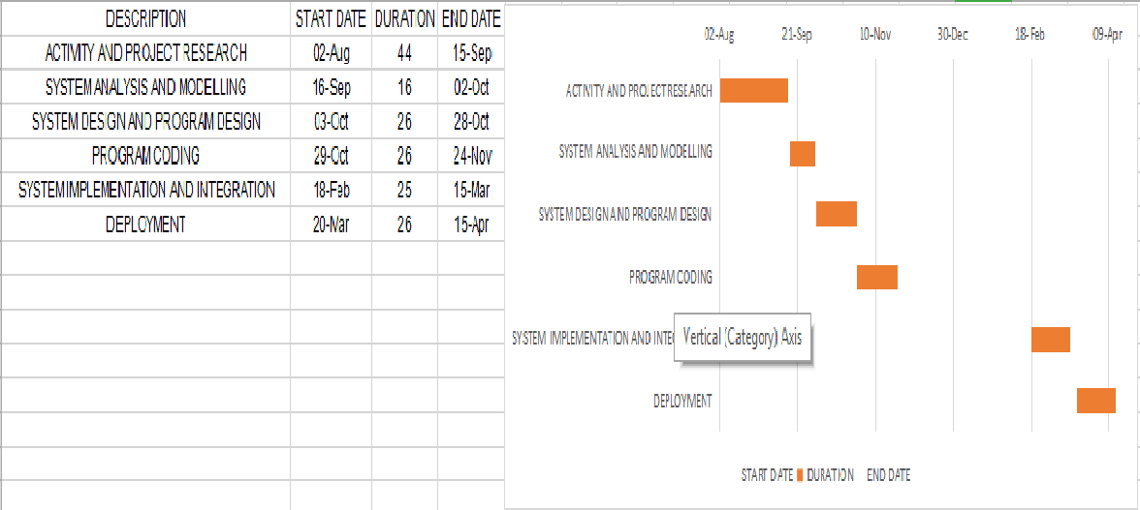

**System Design**

**Data Flow Diagram**

In Figure User starts the Mobile Application and Web Browser and by just connecting the power supply of the raspberry pi there will be interaction with it with the help of wireless internet . The user can by shutting down the power supply of the raspberry pi.

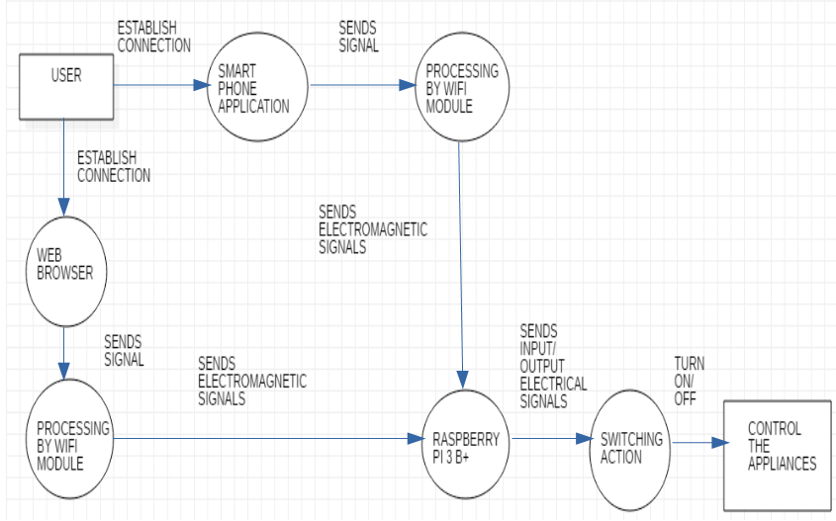

**USE CASE DIAGRAM**

Use case represent typical set if scenario that help us to structure, relate and understand the essential requirements of the target system from the user’s perspective. Use case diagram can be used to describe the functionality of the system in a horizontal way.

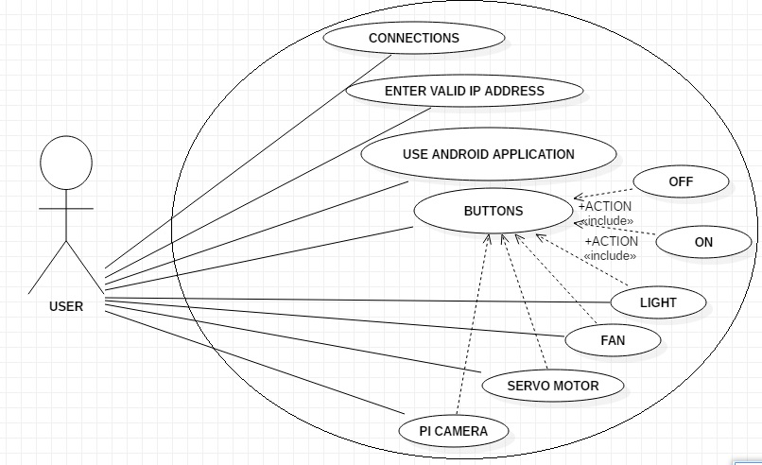

**USE CASE SCENARIO:**

Step 1: get connection.

Step 2: user login through ip address/ mobile application.

Step 3: user get information about devices state.

Step 4: user on or off devices according to their needs.

**USE CASE DESCRIPTION**

User gets connect to the same network that of raspberry pi is connect .User checks whether the device is switch on or off, and then switches on or off according his need .

**When user click on button to switch stages from on to off then the connection between the led /fan/servo motor and get broken and that appliance stops glowing. When user click on button to switch stages from off to on then the connection between the led/fan/ servo motor will get established and that appliance will start working.**

**Circuit Diagram**

A circuit diagram is a visual display of an electrical circuit using either basic images of parts or industry standard symbols.

Symbol usage depends on the audience viewing the diagram. These two different types of circuit diagrams are called pictorial (using basic images) or schematic style (using industry standard symbols).

**Circuitry Board of Raspberry Pi:**

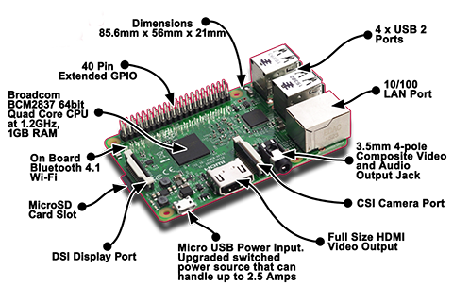

**Activity Diagram:**

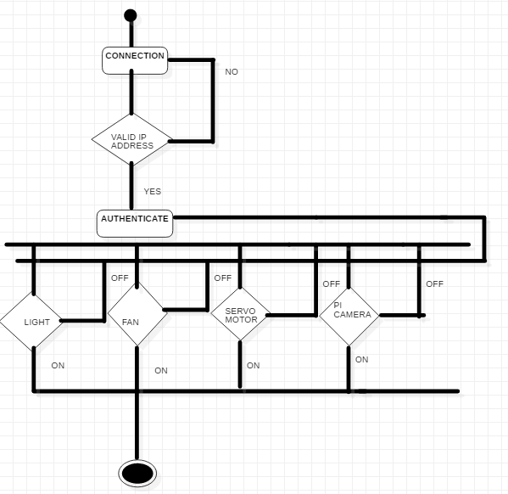

**ER DIAGRAM:**

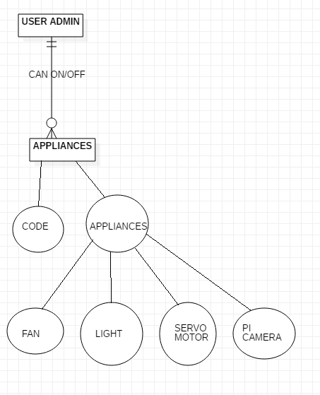

**SEQUENCE DIAGRAM**

**SEQUENCE DIAGRAM**

Sequence diagram describe interactions among the classes in terms of an exchange of messages over time. Sequence diagrams demonstrate the behavior of objects in a use case by describing the objects and the messages thy pass. By examining these messages in detail the functionality and data associated with each of these objects such as operations, attributes can be discovered. The diagrams are read left to right and descending.

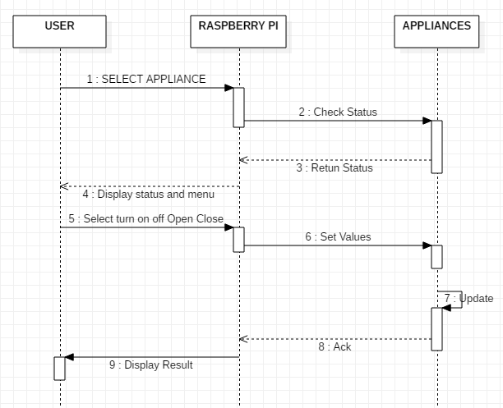

**System Implementation**

**CODE HAS BEEN REMOVED BY ME FOR PRIVACY AND CONFIDENTIALITY CONCERNS**

**METHODOLOGY USED**

**Methodology Adopted:**

In Spiral-SDLC model starts with a small set of requirement and goes through each development phase for those set of requirements. The spiral model adds functionality for the additional requirement in every-increasing spirals until the application is ready for the production phase.

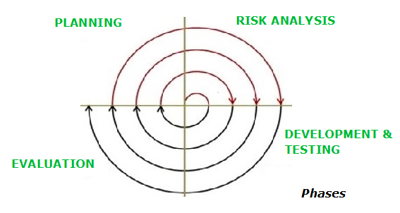

**USER MANUAL**

**Screenshots:**

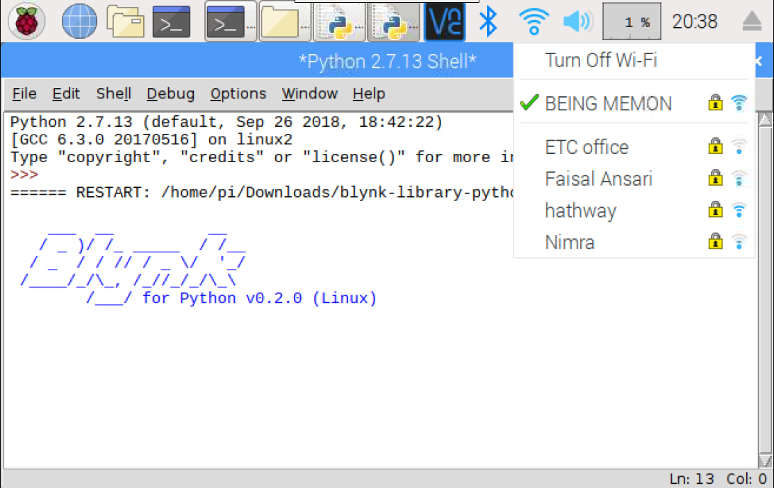

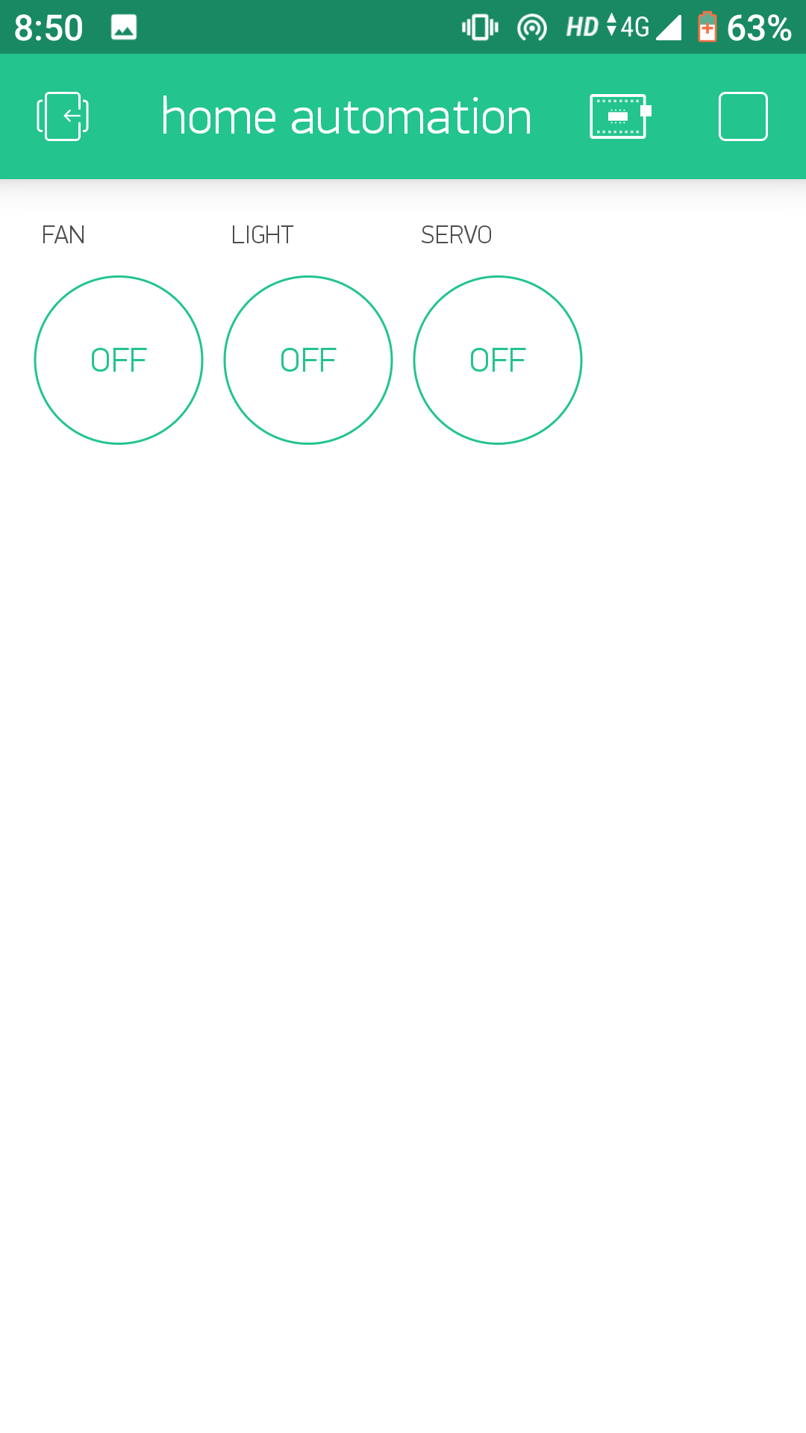

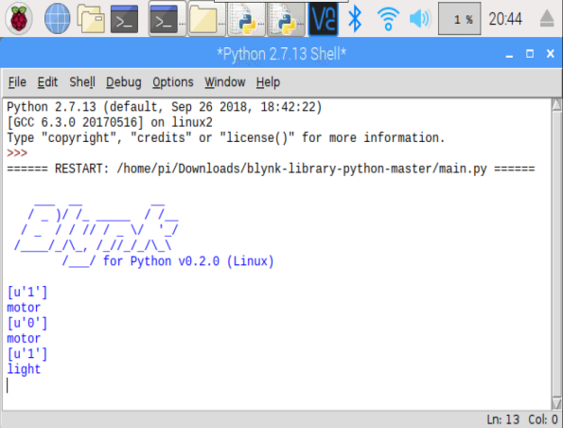 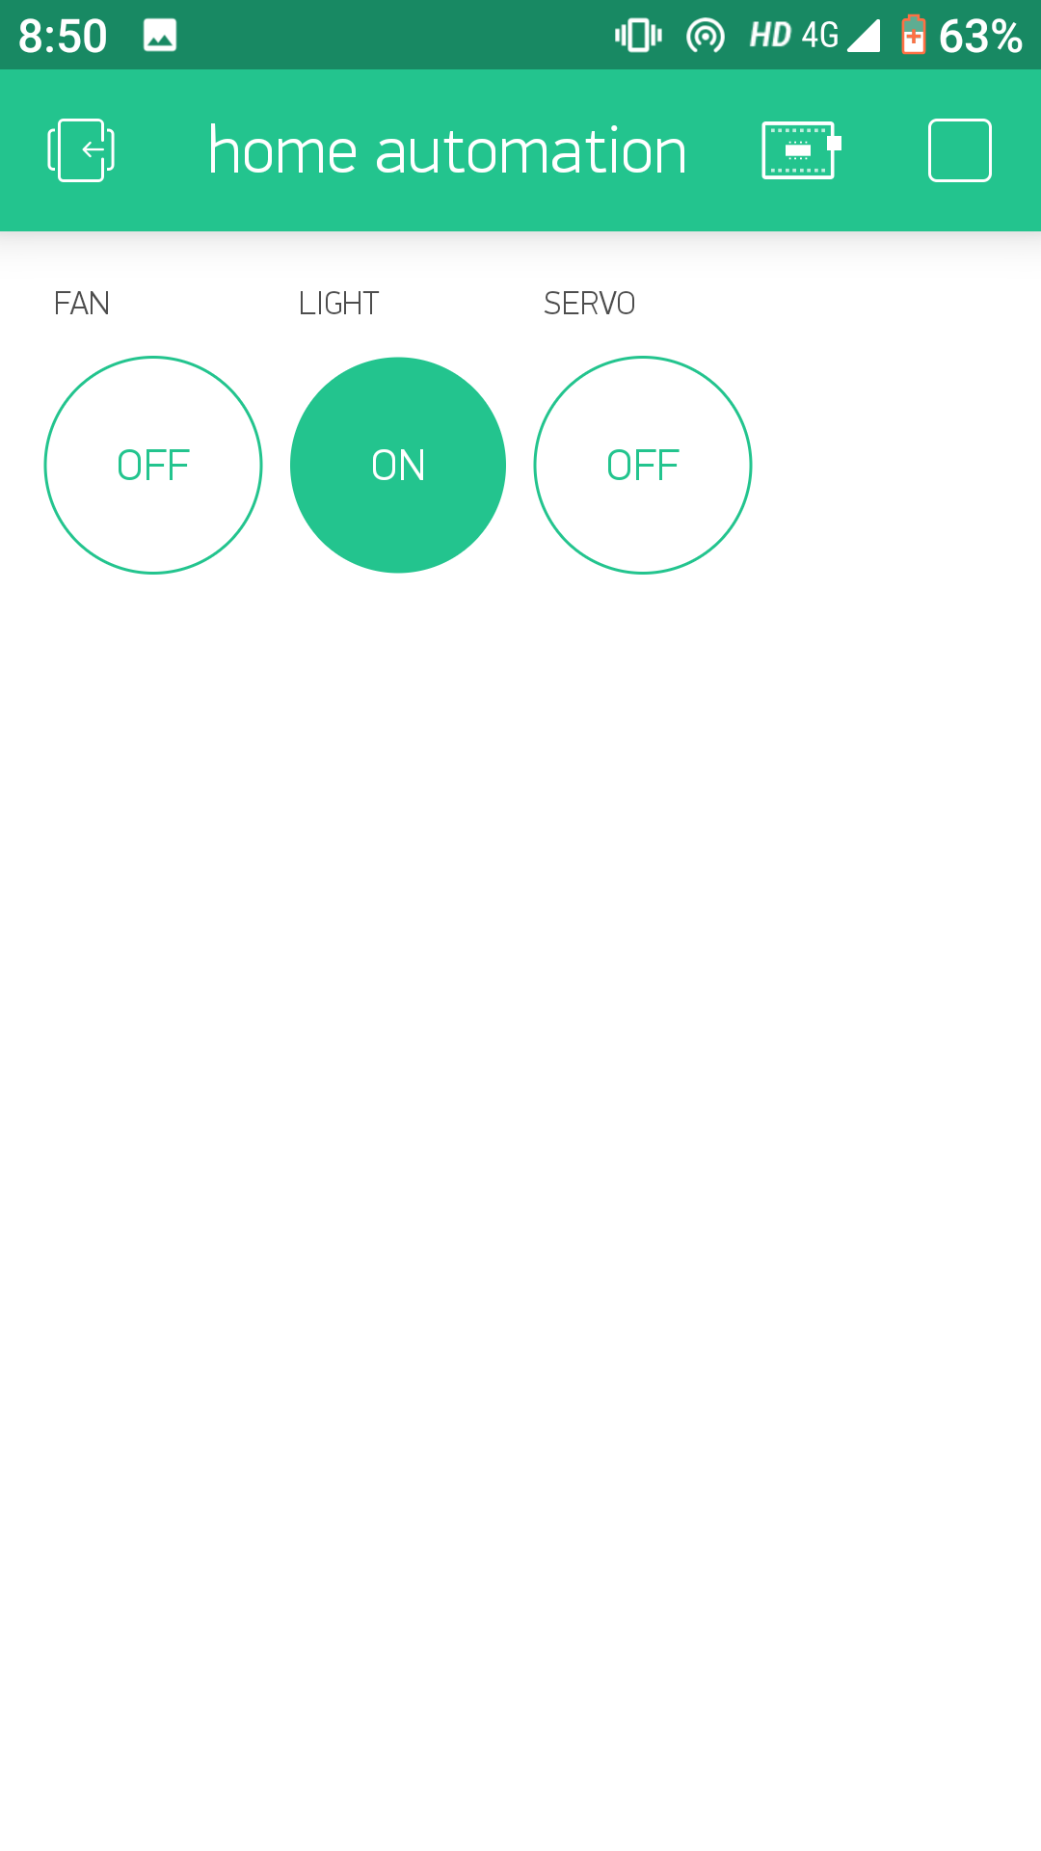

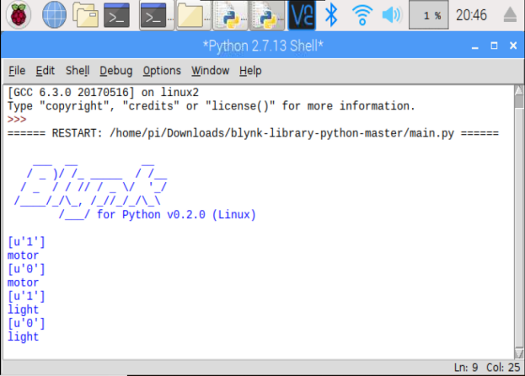 

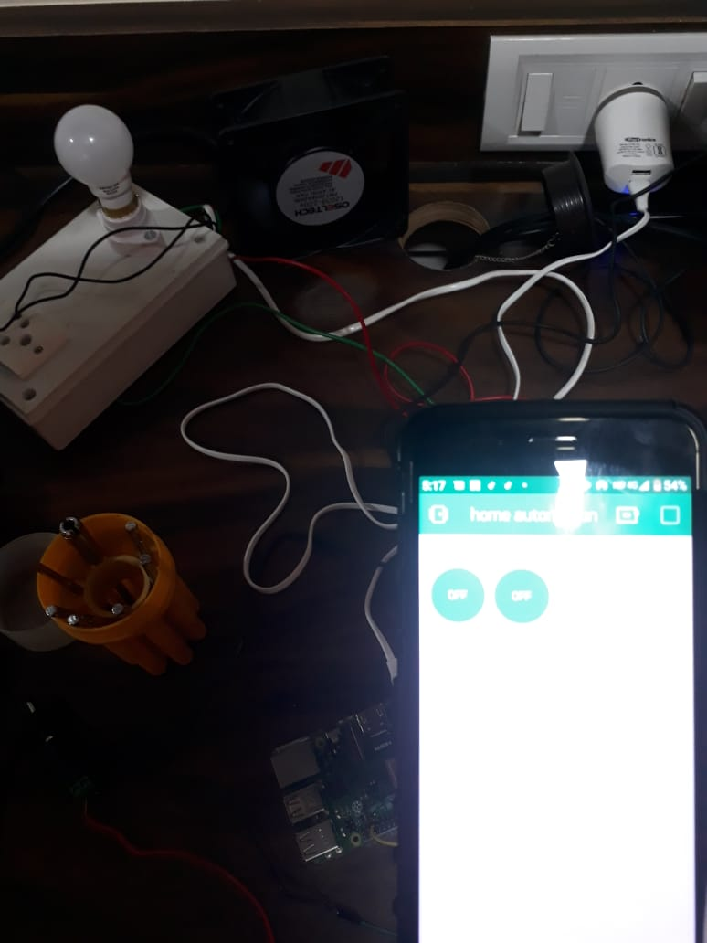 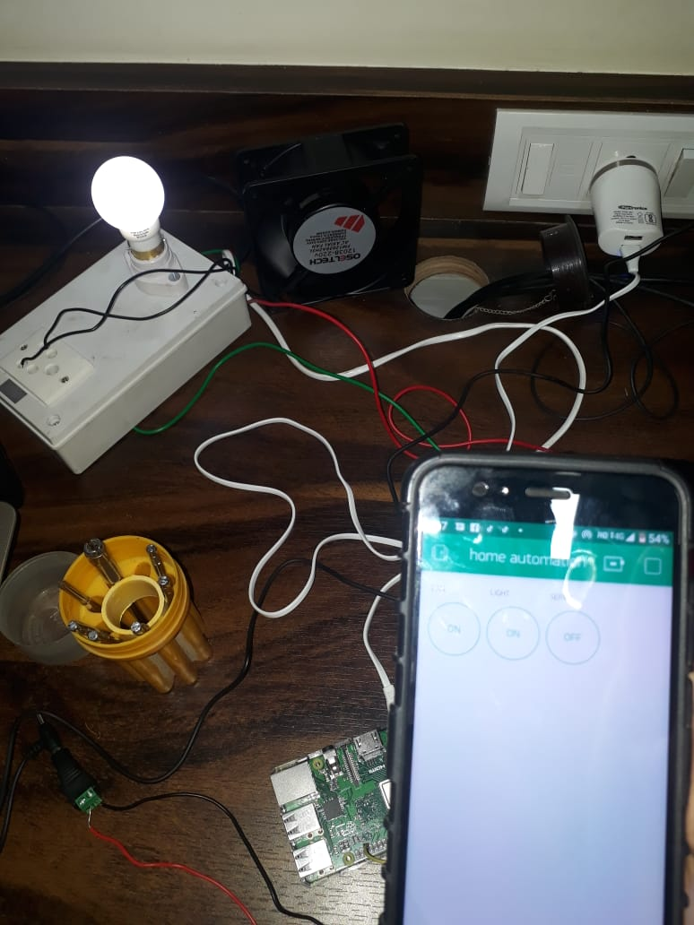

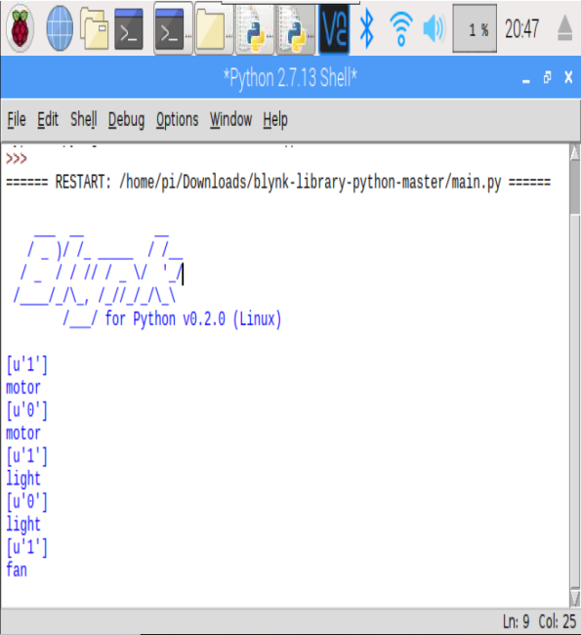 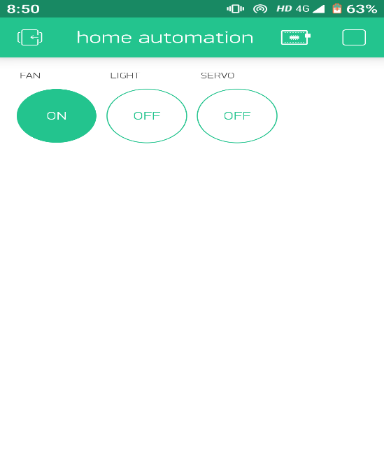

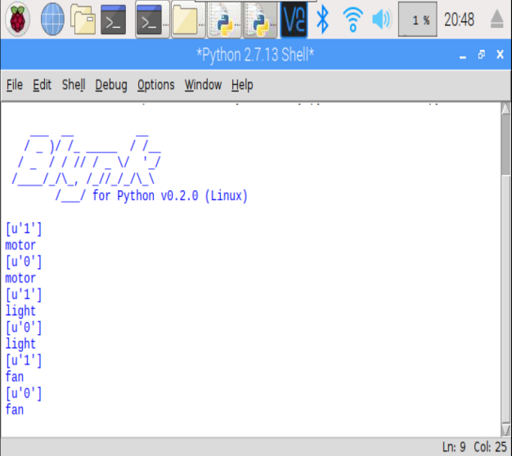 

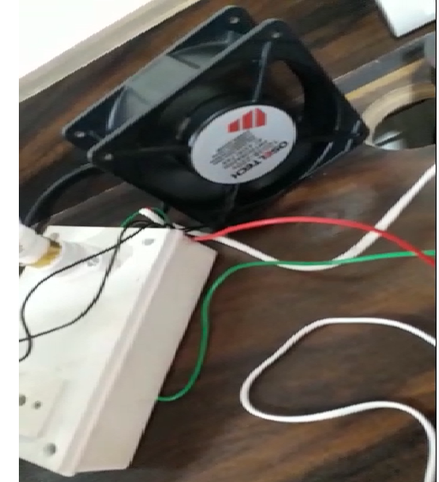 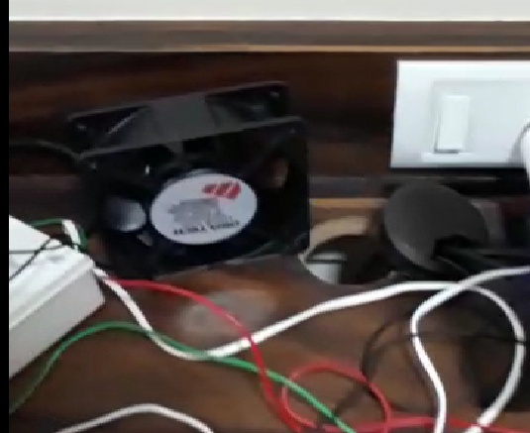

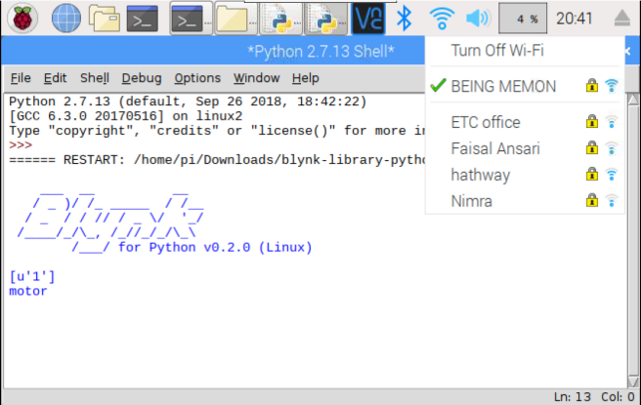 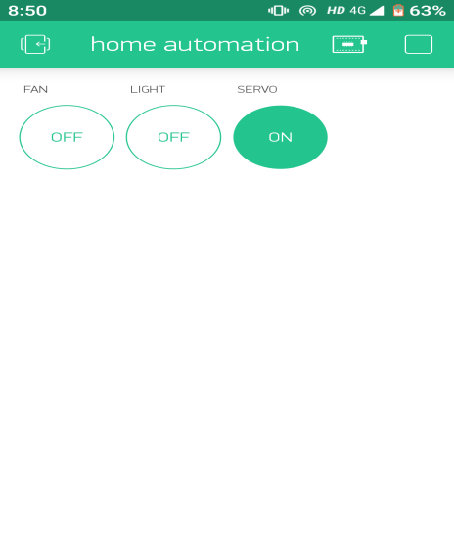

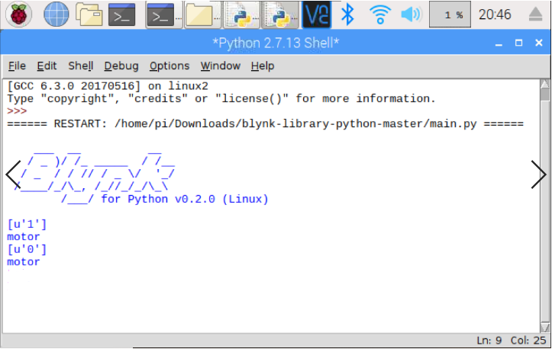 

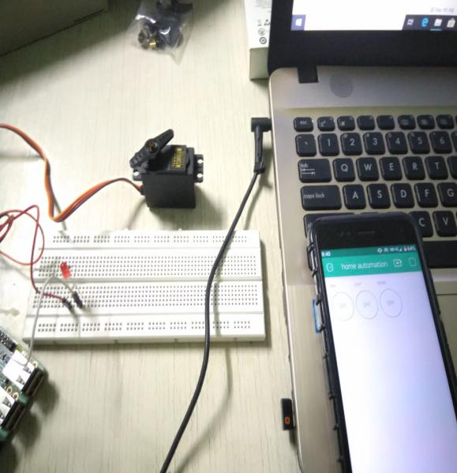 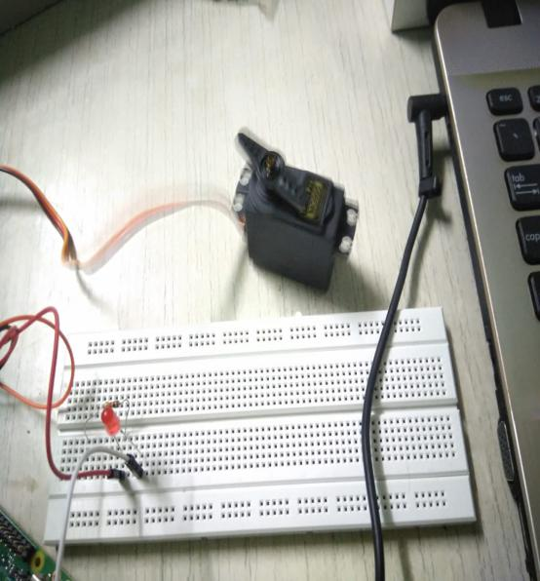

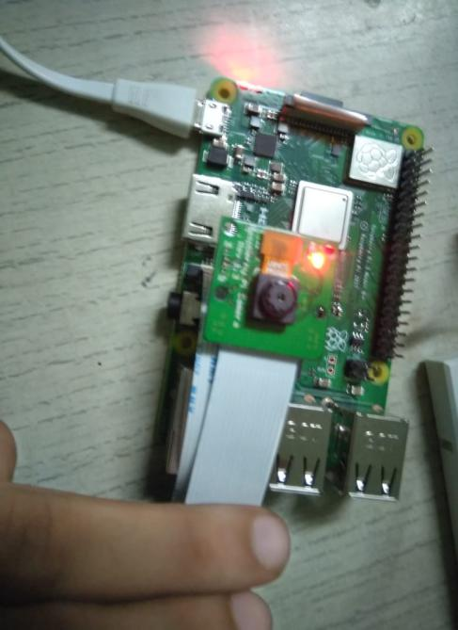 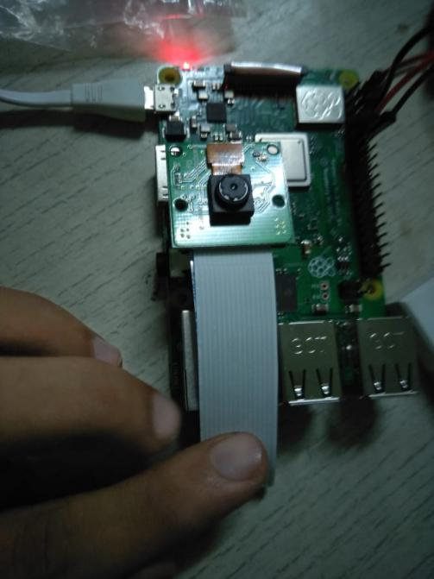

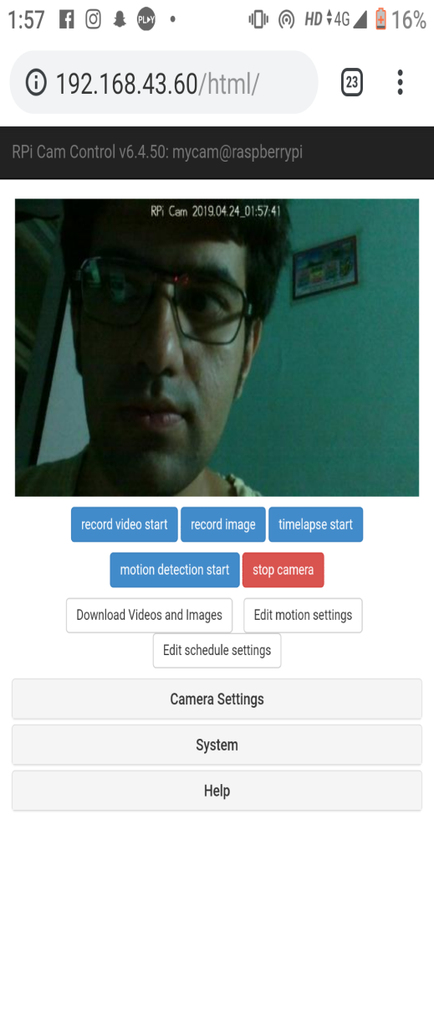 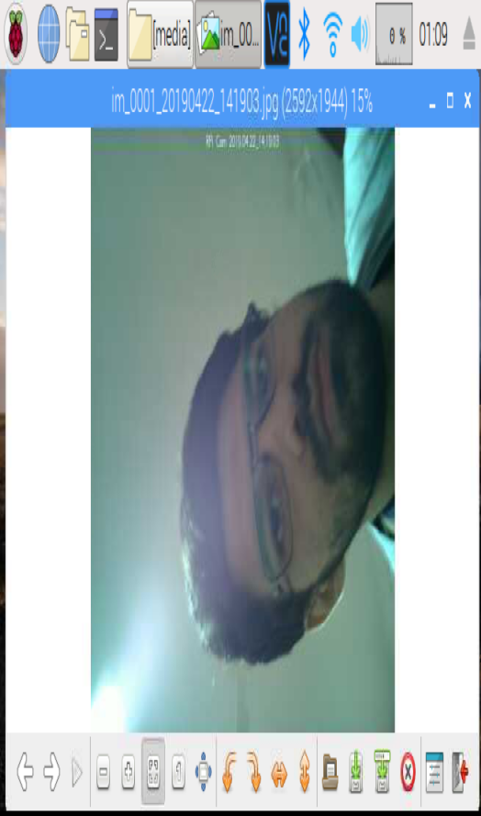

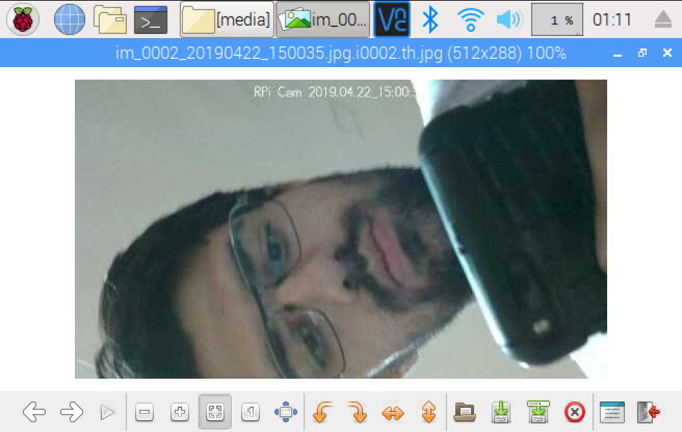

**Steps:**

1. Open the terminal in raspberry pi
2. Make sure Root access is enabled
3. Open the Menu and select Python2 IDLE
4. Go to File tab and Open the main.py file
5. Go to the Run Tab and select Run Module.
6. The main.py file has started
7. Now Open the android application (Blynk App)
8. Tap the interface once and then the play button occurs
9. Click on play button
10. There will be successful connection established then
11. Tap then Light Button or Fan button to turn on and off the appliances.
12. To access the Pi Camera module
13. Attach the PI Camera to the Camera Interface Of the Raspeberry PI precisely
14. Change the directory to **cd RPi_Cam_Web_Interface and then**
15. **Run the start.sh script after success full startup.**
16. **Open the mobile phone browser and enter the valid ip address of the raspberry pi.**

**System Testing**

**Testing Methodology**

Testing is a process of executing a program with the intent of finding errors. A good test case is one that has a high probability of finding an as yet undiscovered error. A successful test is one that uncovers an as yet undiscovered error.

If testing is conducted successfully, it will uncover error in the software and testing demonstrates that software functions appear to be working according to specification, that behaviour and performance requirements appear to have been met. In addition, data collected as testing provide a good indication of software reliability and some indication of software quality as a whole. But testing cannot show the absence of errors and defects, it can only show that errors and defects are present.

**Testing Methodology to be adopted**

All testing should be traceable to customer requirements.

* Test should be planned long before testing begins.
* Testing should begin in small scale and progress towards large scale.
* Exhaustive testing is not possible.
* To be most effective testing should be conducted by independent third party.

**Testing Methods:**

Test must be designed with the highest likelihood to find possible errors in the system to avoid major problems before the system goes live. There are two methods to design the test cases.

**White box testing:**

Glass box testing is a test case design method that uses the control structure of the procedural design to drive test cases. Using white box testing the software engineer can derive test cases that

* Guarantees that all independent paths within the module have been exercised at least once.
* Exercise all logical decisions on their true and false side.
* Exercise all loops at their boundaries and within their operational bounds.
* Exercise internal data structures to ensure their validity.

**Black box testing:**

Black box tests are used to demonstrate that software function are operational, that input is properly accepted and output is correctly produced. It is also used to demonstrate that integrity of external information is maintained. Black box test examines some fundamental aspects of system with little regard for the internal logical structure of the software.

**Verification and validation:**

Verification refers to the set of activities that ensure, software correctly implements a specific function. Validation refers to different set of activities that ensures the software that has been built is traceable to customer requirements.

**Types of testing**

**Alpha testing:** It tests the software at the developer’s site. Software testers conduct the tests using information about customer requirements. It is usually done in the presence of the developer.

**Beta testing:** It tests the software at the client’s site. End user performs testing in absence of the developer and lists down all error and problems occurred during the testing.

**System testing:** Tests to examine compatibility of software with hardware such as CPU, RAM, and disk drives, etc.

**Recover testing:** Uses test cases to examine how easily and completely system recovers from disasters such as power failure, or disk crash or any natural disaster.

**Performance testing:** Tests the performance level of the software when load is low and when load is heavy or regular and records the amount of resource that the software uses.

**Software testing strategies adopted**

The following are the different perspectives we tested:

* Internal program logic by “white box” test case design technique.
* Software requirements using “black box” test case design technique.

After testing individual components integration was done. After integration testing of the software, the software was tested as a whole. Finally, a series of tests were executed once the full program was in operation.

**Unit Testing:** All unit testing will be done in White Box fashion. Testing will be conducted using Basis Path testing methods, because of its simplicity and high effectiveness. Loop testing will be conducted to compliment Basis Path testing. Individual component are tested separately. Due to system’s modular design, there is no need for test beds.

**Integration Testing:** The interface of the modules is tested. Using black box techniques, the interfaces and the linking of different modules is checked for flaws. Any connections to faulty interface are made.

**Functional Testing:** Testing will be done in the black box fashion to check the functionality of the system as a whole. Using different test cases, the logic of the system is checked for flaws.

**System Testing:** In system testing, the system as a whole is observed and checked to see if it meets the user requirement. We tested it again using actual real-life scenarios and data.

**TEST CASES:**

|  |  |  |  |
| --- | --- | --- | --- |
| **Title** | **Home Automation Performance Testing** | **Components: Light, Fan, Servo Motor, Pi Camera** |  |
| **Description** | **Testing all Modules of Home Automation System One by One** |  |  |
| **Test Number** | **Steps/ Action** | **Expected Output** | **Pass / Fail** |
| **1** | **Light Module on the Home Automation  System is connected accurately to the GPIO  Pin of the Raspberry Pi using the Jumper  Wires** | **Light is  turned Off and turned On by click of button on the phone** | **Pass** |
| **2** | **Fan Module on the Home Automation  System is connected accurately to the GPIO  Pin of the Raspberry Pi using the Jumper  Wires** | **Fan is  turned Off and turned On by click of button on the phone** | **Pass** |
| **3** | **Servo Motor Module on the Home  Automation System is connected accurately  to the GPIO Pins as well as the power Pin of  the Raspberry Pi using the Jumper Wires** | **Servo Motor will start rotating on the  click of the button using the phone** | **Pass** |
| **4** | **PI Camera Module on the Home Automation  System is connected accurately to the  camera interface module of the  Raspberry PI** | **After the Valid IP address has been  entered on the phone's browser the on-board red camera indicator should be turned on and the live camera should be displayed  on the phone's browser** | **Pass** |

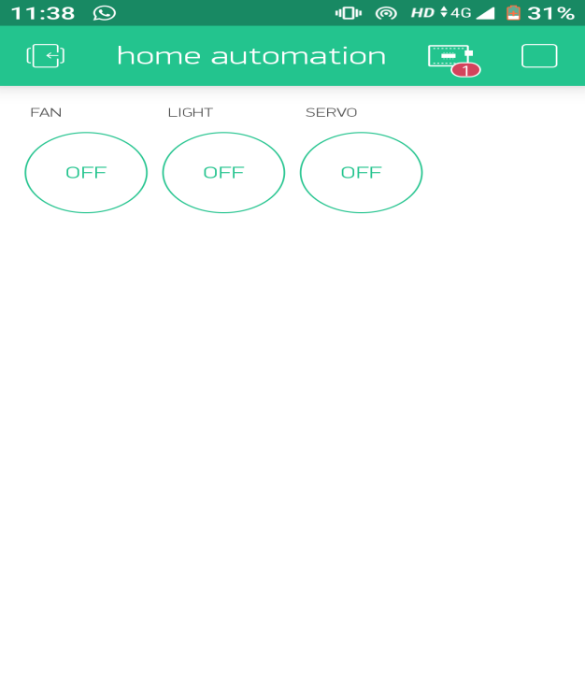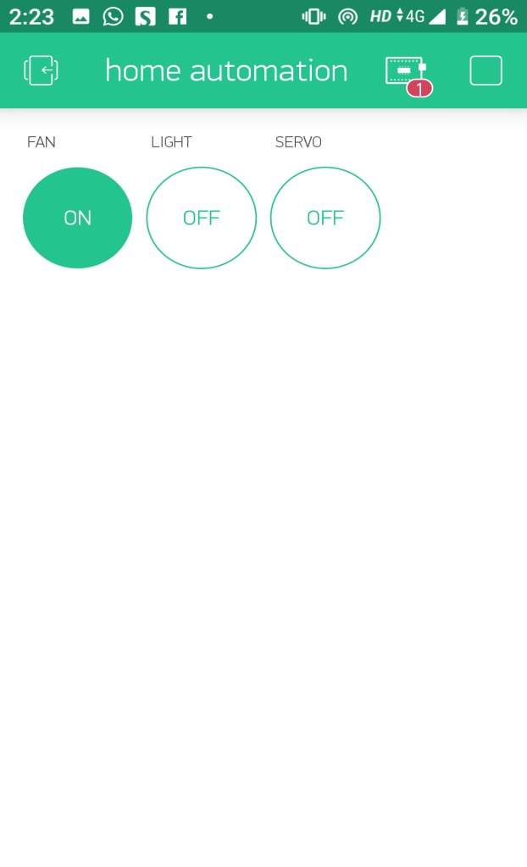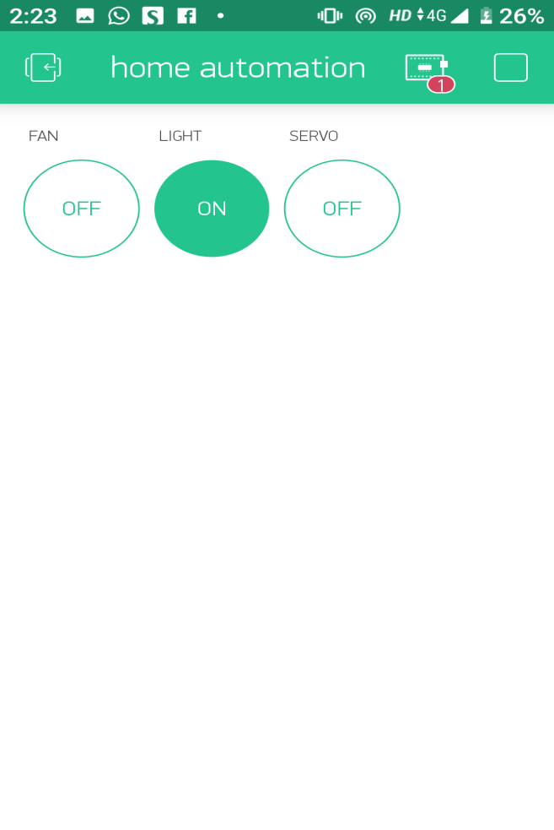 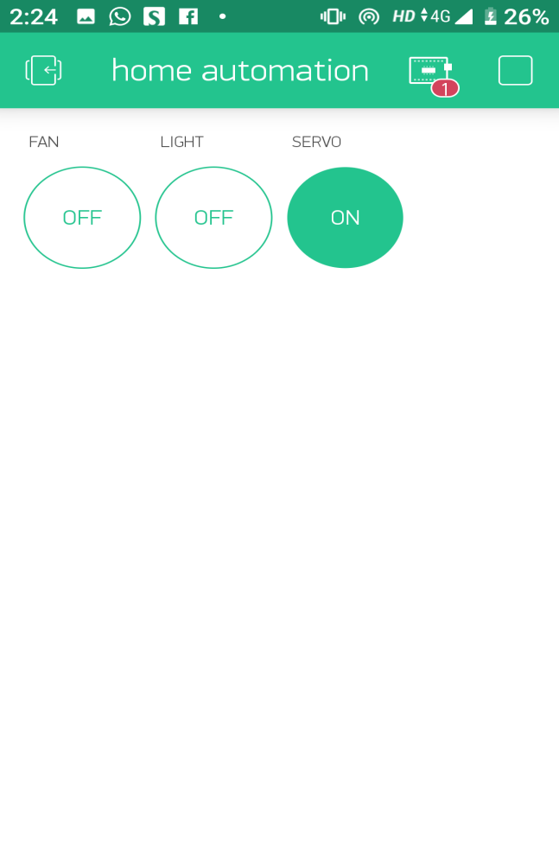

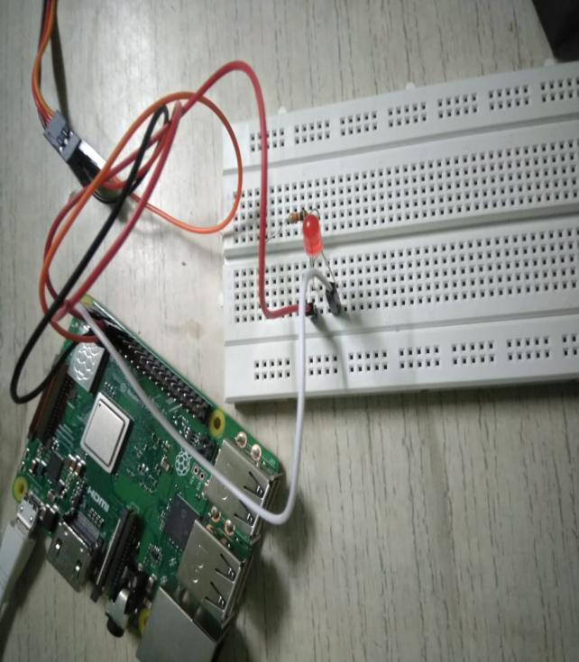 

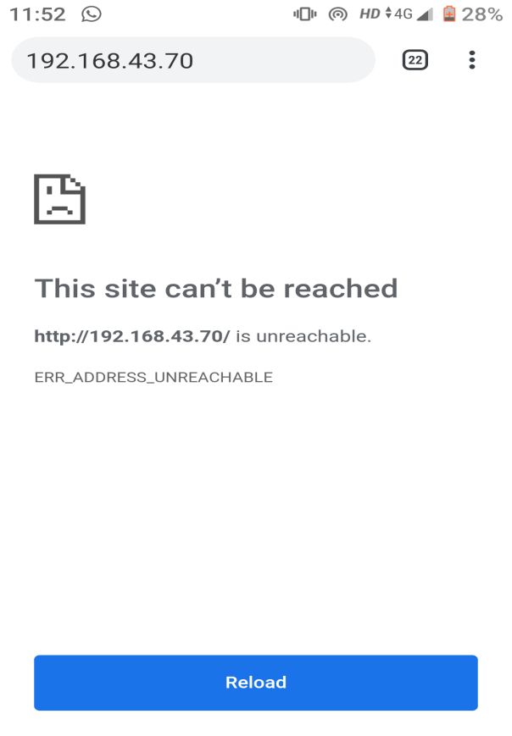 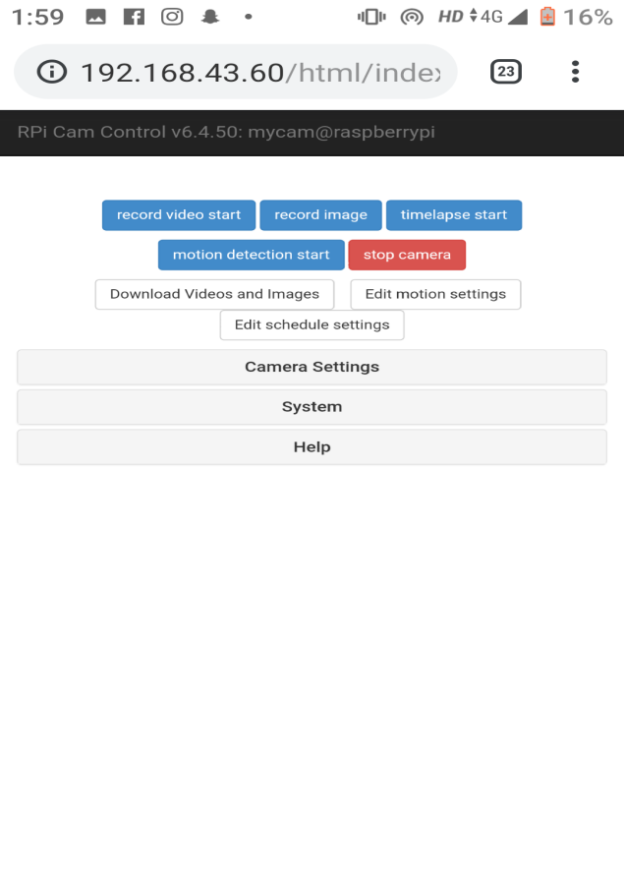

**CONCLUSION AND FUTURE ENHANCEMENTS**

**CONCLUSION:**

**CONCLUSION OF THIS SYSTEM IS AS FOLLOWS:**

This system successfully gives the access to turn on and off all the appliances associated with it. These appliances are accessed remotely and the system is also capable of providing a very user friendly interface to the user of the system.

It will also provide help to the disabled people who are admitted in the hospitals or at home and also to the senior citizens. As the lights fans and doors are the common things used in houses. Giving this type of access in the hands of the need and achieving the challenging task fulfills the objective of the project.

By completing this there will be increase in rate of interest for the internet will give a clear picture of IOT. People will get to know clearly that technology can change the lifestyle and also help to resolve the human based problems.

**Limitations of Existing System**

Limitation of the system is as follows.

* Lack of computerization leads to time wastage.

Its connection to the internet is slow and limited this means that it takes a little time.

* It was not having a system of computerized working.

its low processing power means that it will not be capable of performing any complex tasks.

* It has to be manually on or off.

The raspberry pi has to be powered on and off manually the user has to power on and off the system in order to use it.

* Requires power supply.

There should be proper power supply provided inorder to power on the raspberry pi and also all the appliances.

* Requires accurate connection of the electrical wires and appliances.

The system needs an accurate connection of all the appliances to the raspberry pi so it could function properly.

**FUTURE ENHANCEMENTS:**

The software developed as part of the project can further be enhanced as follows:

* This project can be used by multiple people at a single point of time
* A call on user’s smart-phone when someone rings the doorbell.
* Connection of database can be made to store the data for those who used all of the appliances.
* Security can be improved by providing Username and password.
* More interactive UI can be developed.
* More of appliances can be added to the system.
* System can be made on a very larger scale with high performance factor.
* There can be access added by implementing the technology of cloud computing.
* Speech recognition and biometric key unlocking system for security.

**REFERENCES**

**REFERENCES:**

1]

Mohd. Rihan, “Evolution of Home Automation Technology”, BIJIT-BVICAM’s International Journal of Information Technology, Bharati Vidyapeeth Institute of Computer Applications and Management(BVICAM), Vol.1 No.2, pp. 119-124, December 2009.

2]

Mamata khatu, Neethu Kaimal, Pratik Jadhav, Syedali Adnan Rizvi, “Implementation Of Internet of Things for Home Automation” IJEERT-International Journal of Emerging Engineering Research and Technology, ISSN:2349-4395(Print) & ISSN:2349-4409(Online), Volume 3, Issue 2, February 2015.

3]

1. Vidyasagar, G. Balaji, K. Narendra Reddy, “Android Phone Enabled Home Automation”, JAIR-Journal of Academia and Industrial Research, ISSN: 2278-5213, Volume 4, Issue 2 July 2015.

4]

Nupur Tyagi, “A REFERENCE ARCHITECTURE FOR IoT”,in International Journal of Computer Engineering and Applications, Volume X, Issue I, Jan. 1www.ijcea.com ISSN 2321- 3469.

5]

SomayyaMadakam, R. Ramaswamy, SiddharthTripathi, “Internet of Things (IoT): A Literature Review”, Journal of Computer and Communications, 2015, 3,164-17

6]

White Paper What the Internet of Things (IoT) Needs to Become a Reality.

7]

Pooja N.Pawar, Shruti Ramachandran, Nisha P.Singh, Varsha V.Wagh “A Home Automation System using Internet of Things”in International Journal of Innovative Research in Computer and Communication Engineering (April 2016).

8]

Nikhil Singh, Shambhu Shankar Bharti, Rupal Singh, Dushyant Kumar Singh, “REMOTELY CONTROLLED HOME AUTOMATION SYSTEM”, IEEE International Conference on Advances in Engineering & Technology Research (ICAETR - 2014).

**Websites Used:**

|  |  |  |
| --- | --- | --- |
| • | Google | - [www.Google.com](http://www.google.com/) |
| • | Youtube | -www.youtube.com |
|  | Github | -www.github.com |
|  | Hackster | -www.hackster,io |
|  | Raspberry PI | -www.raspberrypi.org |
|  | Blynk | - www.blynk.io |